Remaining Issues

GSL function double gsl_cdf_fdist_Pinv (double P, double nu1, double nu2)
For NU2 > 200.
Can resolve for PC by using the Rmath library. Could use chi-squared approx qchisq(0.9,1) which is limit as Nu-> infintity for MAC??

plot(x, qf(0.95,1,x), ylim= c(3.6, 3.9))
points(x,qchisq(0.95, 0*x+1))
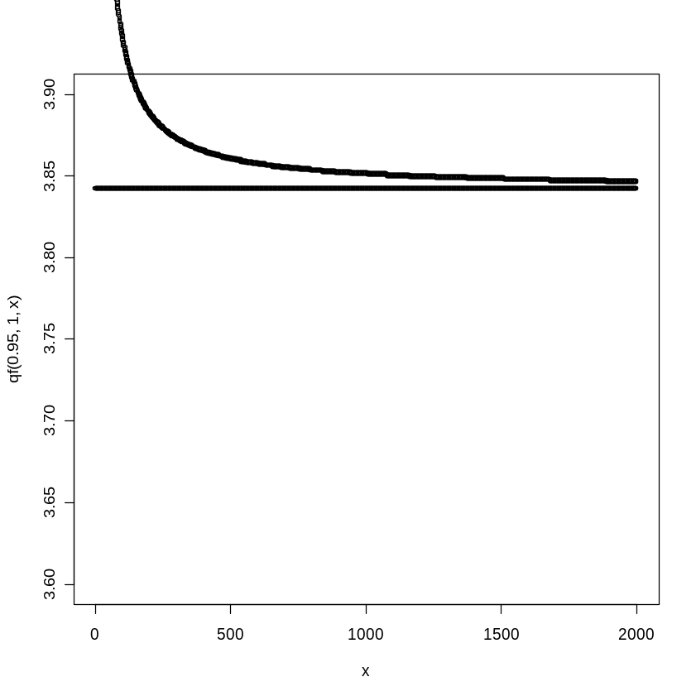
Problem with data transfer between operating systems because of newline characters.

I have read up on our problem a bit further and it seem's it's a classic (http://en.wikipedia.org/wiki/Newline) cross-platform problem (ie. not my fault). Linux uses '\n' for newline, windows uses '\n' or '\r\n' and mac '\r'. I have implemented a fix so that SMATR now works with MAC-style files, BUT that means it won't work with input files from DOS. So you need to decide whether you want a binary which reads DOS or MAC files. I presume the latter is preferable. There is a way to convert between them:
You can convert a DOS file to MAC by typing at the command line,
tr -d '\r' <dos.txt> temp.txt
tr '\n' '\r' <temp.txt> mac.txt
and for MAC to DOS
tr '\r' '\r\n' <mac.txt> dos.txt
or by downloading program ‘flip’
http://ccrma-www.stanford.edu/~craig/utility/flip/

So you will still be able to open other types of files. unfortunately there is nothing more i can do about this. But i would appreciate your feedback on which option would be preferable so I can distribute this on the website. We haven't discovered any of this before because you guys are the first to use SMATR on mac.

